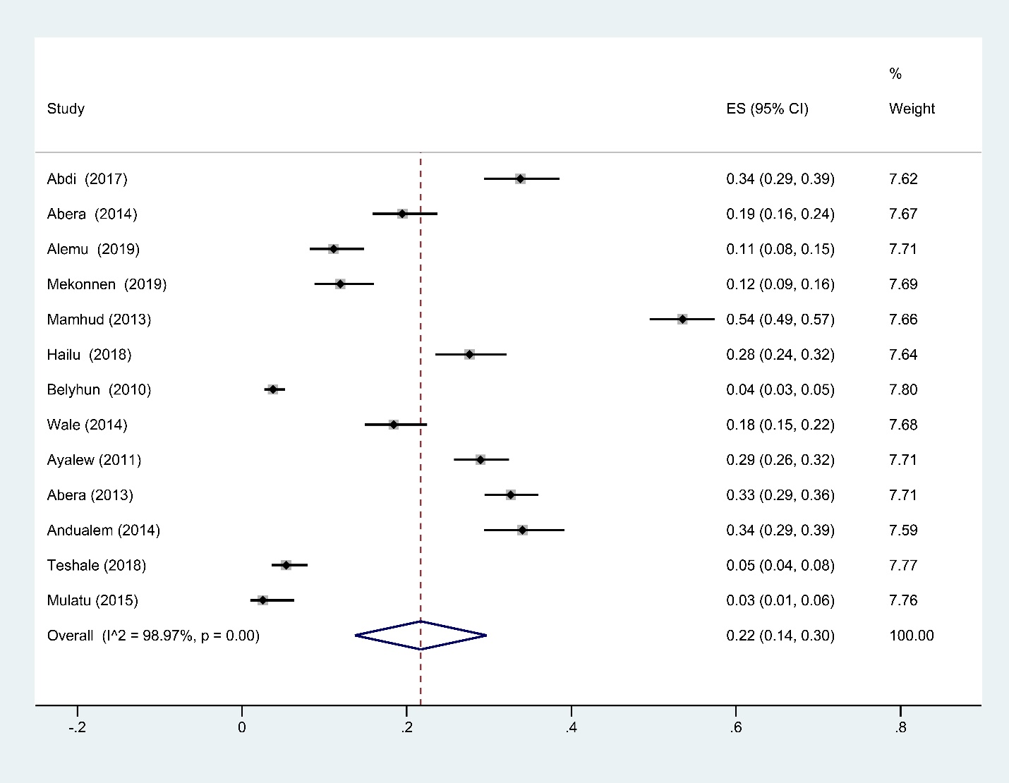
Additional file 1. Forest plot showing prevalence of intestinal parasite infections among rural preschool and school-age children in Ethiopia

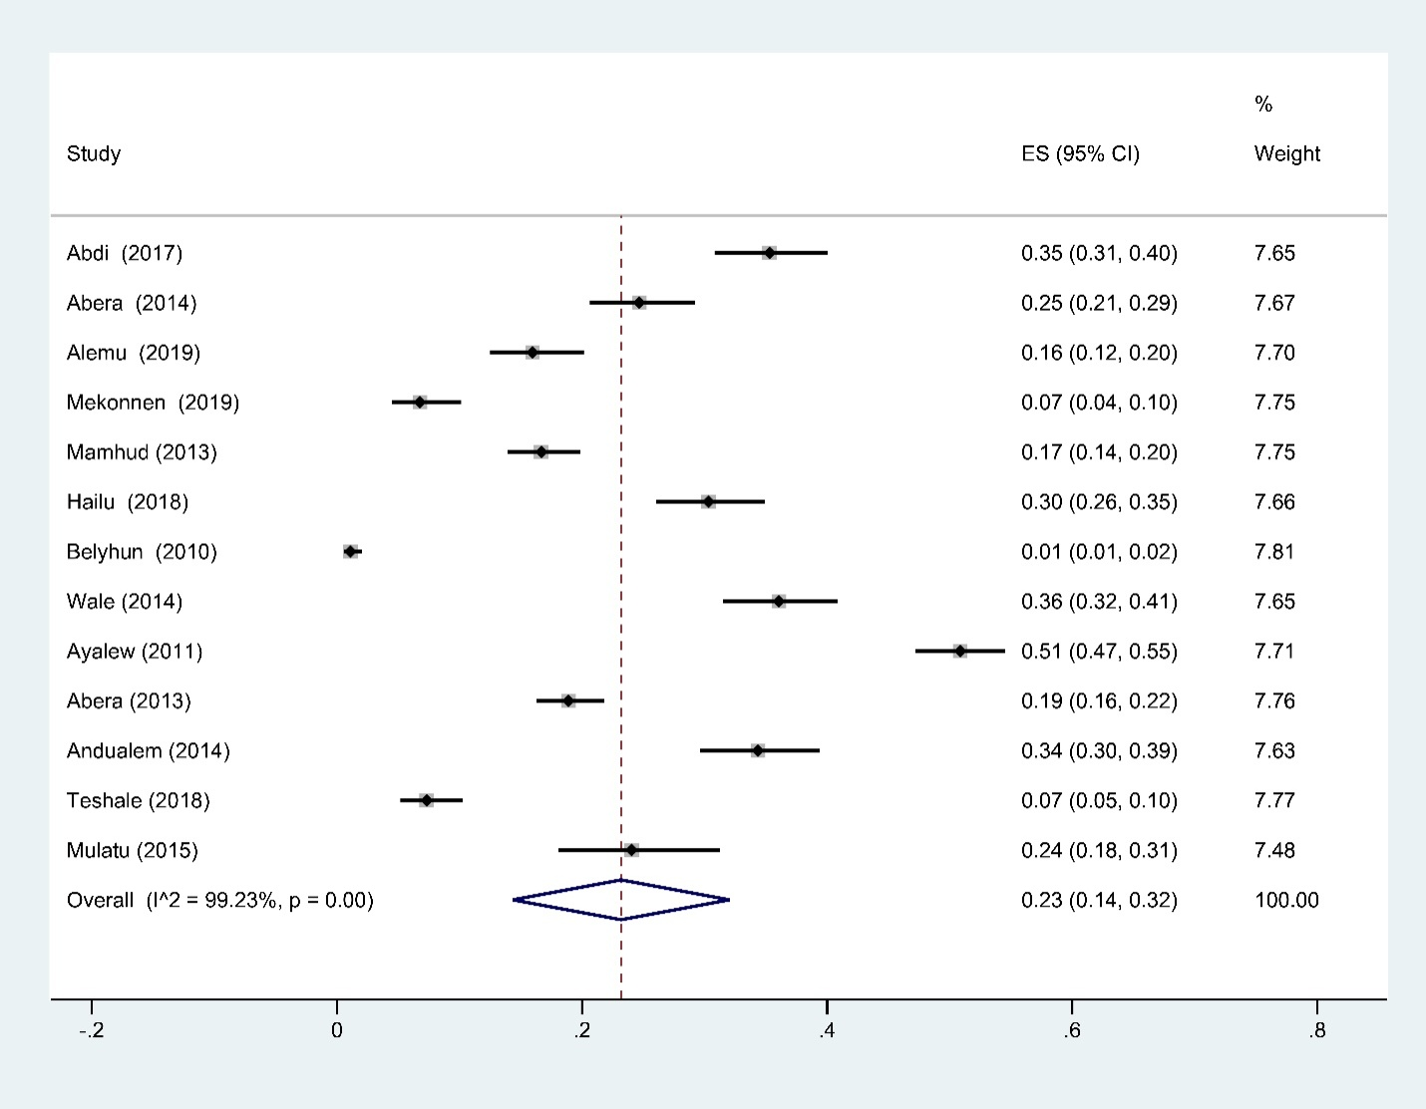 Additional file 2. Forest plot showing prevalence of intestinal parasite infections among Urban Ethiopia children

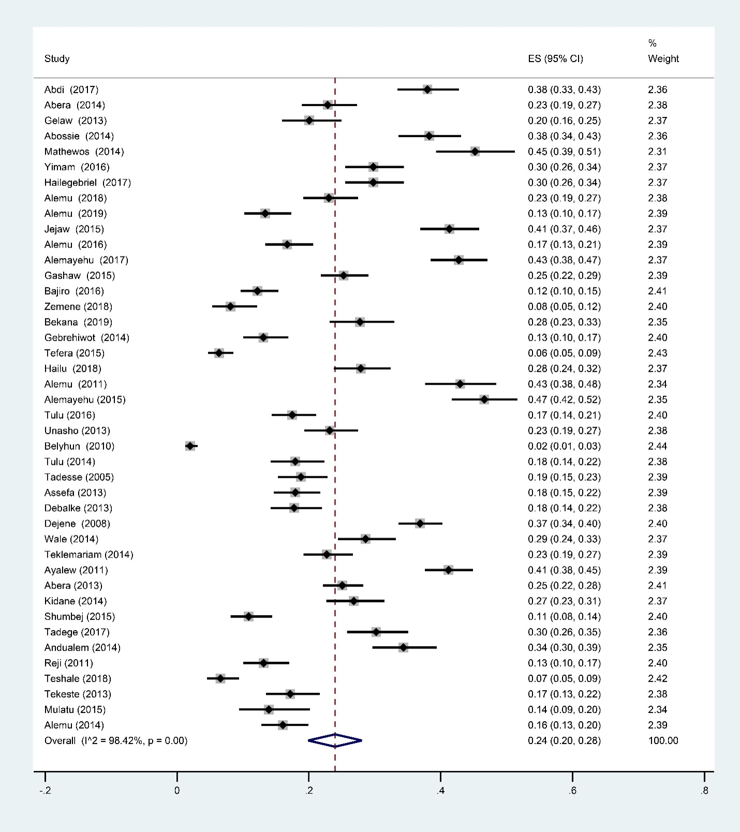
Additional file 3. Forest plot showing prevalence of intestinal parasite infections among male Ethiopian children
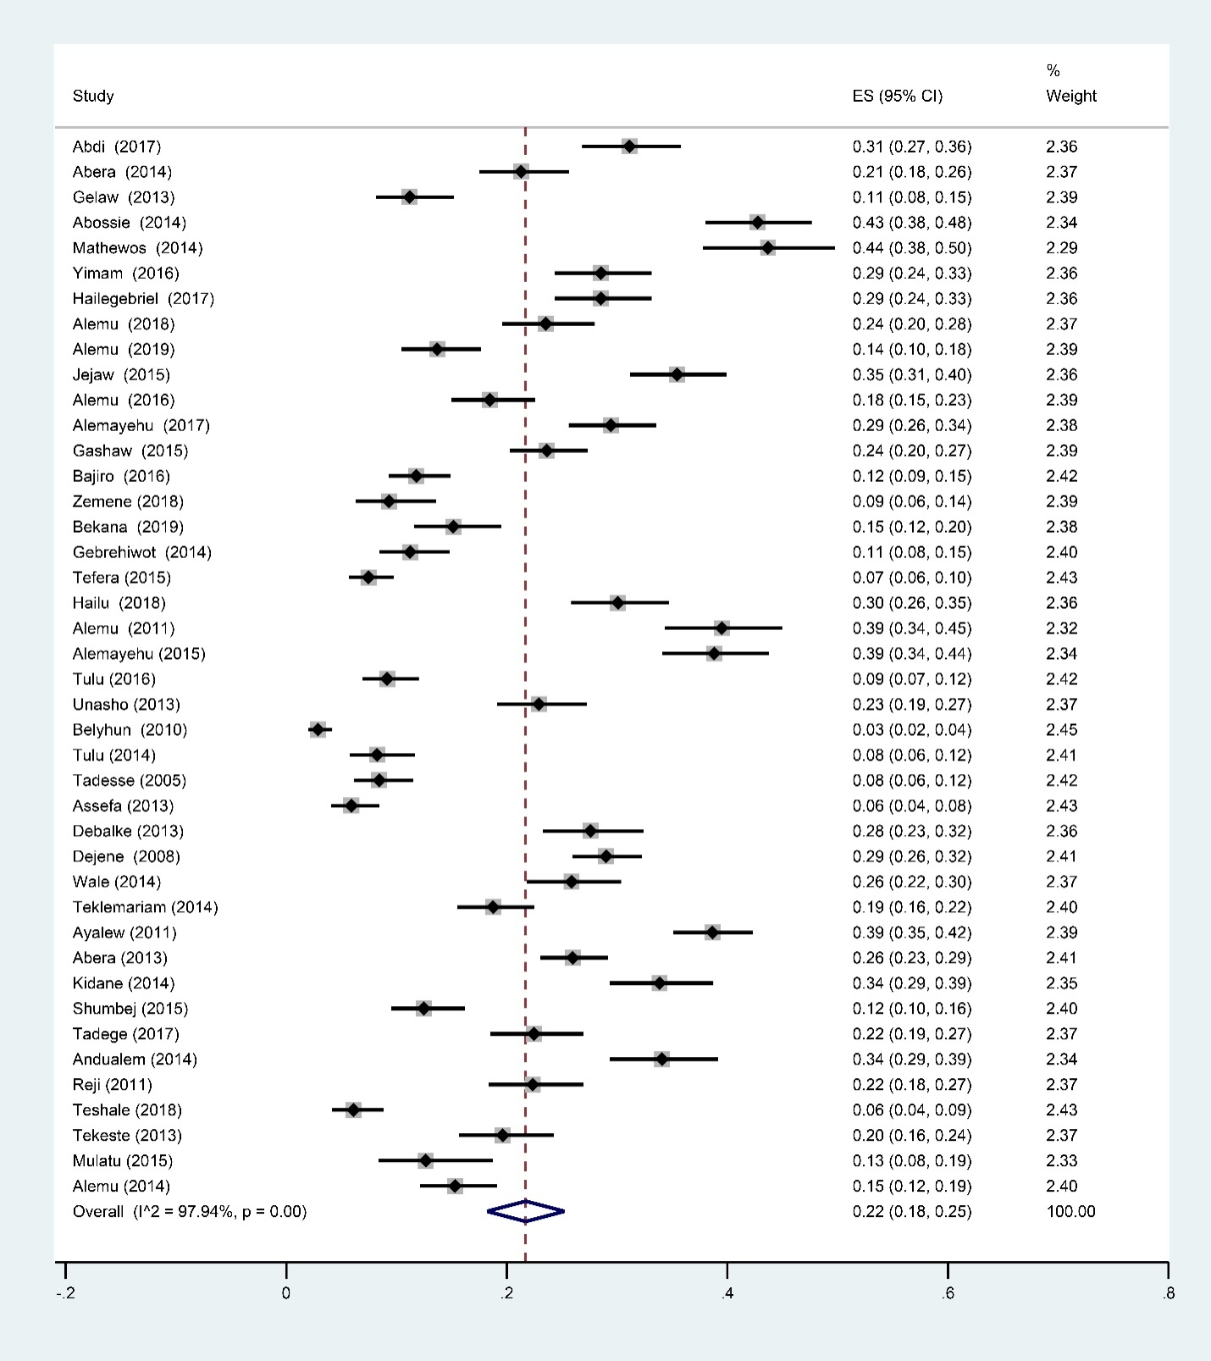
Additional file 4. Forest plot showing prevalence of intestinal parasite infections among female Ethiopian children

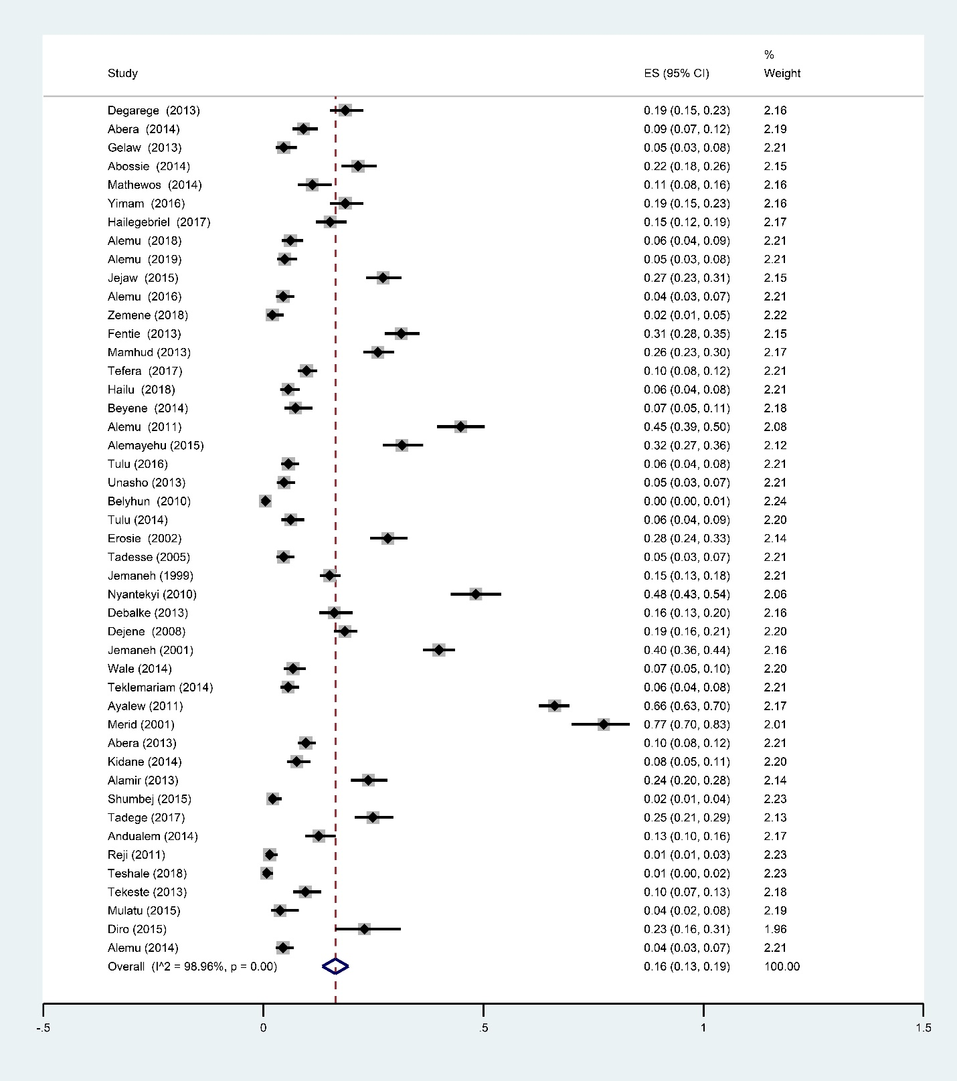
Additional file 5. Forest plot showing prevalence poly-parasitism infections among Ethiopian children

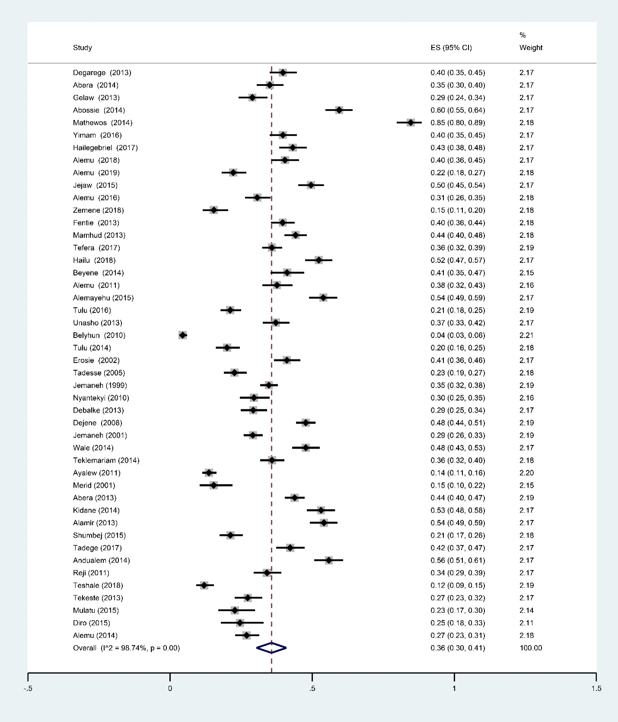
Additional file 6. Forest plot showing prevalence intestinal parasite infections with single species of parasite among Ethiopian children

